Himadri Sekhar Tewari

IST 659

Project Deliverable 1

**Database for an Online Pizza Company**

**Project Summary:**

I want to build a database for an online pizza company. It start with a guest customer entry details or new customer register first time in the webpage by providing the name, address, email and phone number. After successful registration, customer can select pizzas of different sizes and toppings limited to 10 toppings. Customer can select other products present from the product page and can increase or decrease the quantity or remove the item. Only one coupon can be added to an order. A coupon can be either order type or item type. After selecting one or more products and adding in cart, customer can choose the order destination as either carryout or delivery. After selecting the destination, customer can choose the order ready date as current date or future date or future time. After selecting the date/time, customer need to select payment methods (one or more payments are applicable). The different type of payment types is Cash or Credit Card. When selecting cash, customer need to enter only the amount. For credit cards, customer has to enter the card number, expiration date, CVV, name in the card, billing address. Once the card number is entered, card type will be auto selected and the correct card name will be displayed. Customer has the option to save a maximum of 3 cards in the customer account. After selecting the payments, customer has the option to review the order before confirmation. click on Confirm Order button and an order confirmation number is generated in the webpage and an email is sent to the customer in the registered/given email.

Question 1:

Use the database to find out the most popular product

Question 2:

Use the database to compare the sale of current year to last year

Question 3:

What is the most popular delivery method

Question 4:

Sales comparison between guest and registered customer

|  |  |
| --- | --- |
| **Entity** | **Attribute** |
| Customer | CustomerID [ru]  Name [r]  Address[r]  Phone Number [r]  Email address [ru] |
| Product | ProductID [ru]  Product Name [r]  Product Type [r] |
| Coupon | CouponID [ru]  Coupon Name [r]  Description [r]  Coupon Type [r]  Coupon Details [r] |
| Order Source | OrderSourceID [ru]  Source Type [r] |
| Order Destination | OrderDestinationID [ru]  Destination Type [r] |
| Order Ready | OrderReadyID [ru]  Date [ru]  Time [r] |
| Payment Method | PaymentMethodID [ru]  PaymentType [r]  Amount [r]  TransactionType [r] |
| Card Payment Details | PaymentID [ru]  Name [r]  Card Type [r] |
| Customer Account | CustomerAccountID [ru]  Customer Name [r]  Card Type [r]  Card Number [r]  Billing Address [r] |
| Order Detail | OrderDetailID [ru]  Order Confirmation Number [ru]  Order Confirmation Date [ru]  Quantity [r]  Ordered Product [r] |

**Conceptual Model:**

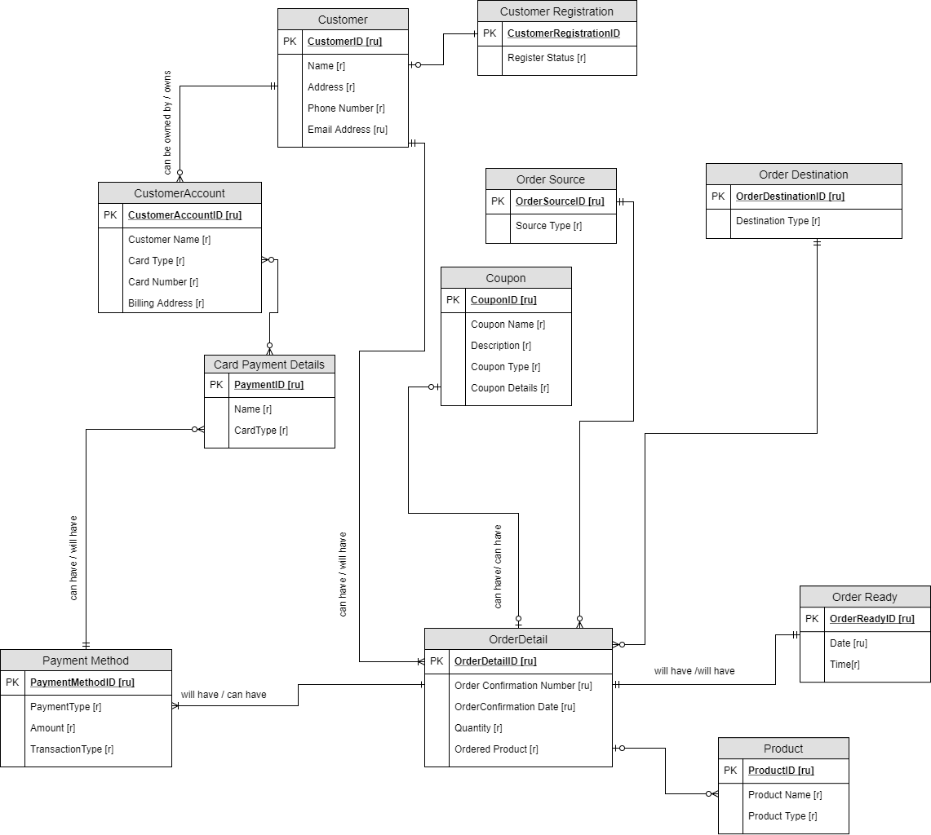

**Normalized Logical Model:**

